Workplace Violence Toolkit – Tool 3e

HOSPITAL LOGO/NAME HERE

Workplace Violence Prevention Program 2017

ABC medical center is in the process of evaluating the violence prevention program.

Your feedback will help the ABC medical center Work Place Violence Committee (WPVC) enhance the violence prevention program at ABC medical center.

OR Your feedback will help the ABC medical center Work Place Violence Committee (WPVC) evaluate the impact of violence prevention processes implemented during the past year and determine how to enhance the program.

Please take a few minutes and go https://www.surveymonkey.com/r/ABCWPVstaffsruvey to complete a quick survey about your experience related to work place violence and violence prevention activities at this facility.
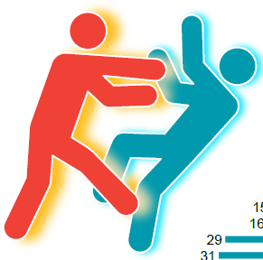

All responses are confidential

Questions? Please contact Joe Smith, WPV Program Coordinator/Director of Nursing at JoeSmith@ABChospital.org

